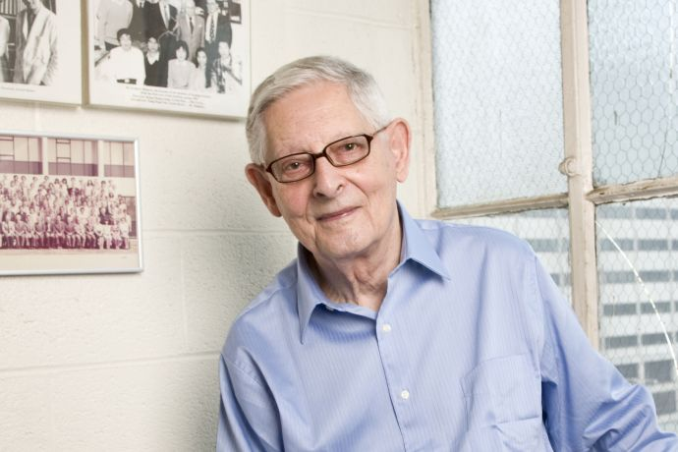
The NYU Polytechnic School of Engineering community mourns the passing of Arnošt Reiser—a respected chemist and professor—on August 4, 2015, at the age of 95. Arnošt Reiser was born in Prague, Czechoslovakia, on July 5, 1920. He graduated from the Institute of Chemical Technology in Prague, and was teaching there as a professor until 1960. After dramatic escaping from communist Czechoslovakia, he was active in chemical research and teaching in Denmark and United Kingdom. He joined the faculty of NYU Polytechnic School of Engineering - then Brooklyn Polytechnic – in 1982.
In industry, Dr. Arnošt Reiser was renowned for his work on a light-sensitive varnish called a “photoresist” that made possible the invention of the transistor and subsequent semiconductor revolution. Within Brooklyn Polytechnic, he was equally renowned for his teaching prowess, deep interest in his students, and willingness to engage with young people—even well after he had retired from the classroom.
The memorial for Dr. Arnošt Reiser will be held at the New York University Polytechnic School of Engineering from 4 to 6:30 PM on Thursday, October 15. to take place in room LC 400 in the Bern Dibner Library of Science and Technology at 5 Metrotech Center, Brooklyn, New York 11201.

If anybody plans on coming to the memorial, let us know by using one of the contacts listed below. You are most welcome to join us to celebrate the life of this distinguished scientist and gentleman. He made a difference.

Mark M. Green
Professor of Chemistry
New York University Polytechnic School of Engineering
Metrotech Center, Brooklyn, NY 11201
646-997-3177 mgreen@nyu.edu

